# DATA DICTIONARY

One can see the columns, relations, unique keys, triggers, dependencies, meta data for each table using the data dictionary.

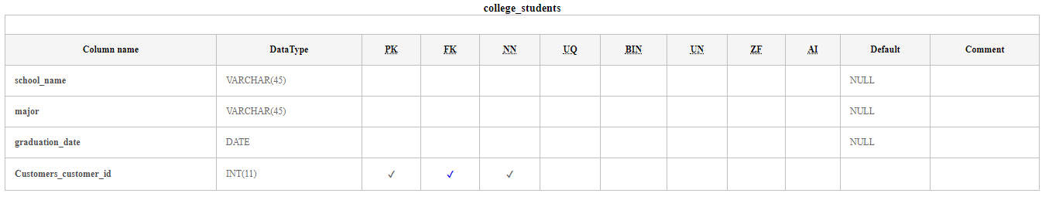

The above table describes about **student** table

Customer_id is Primary key, Foreign Key and cannot be Null value

DataType indicates the data type of the attribute

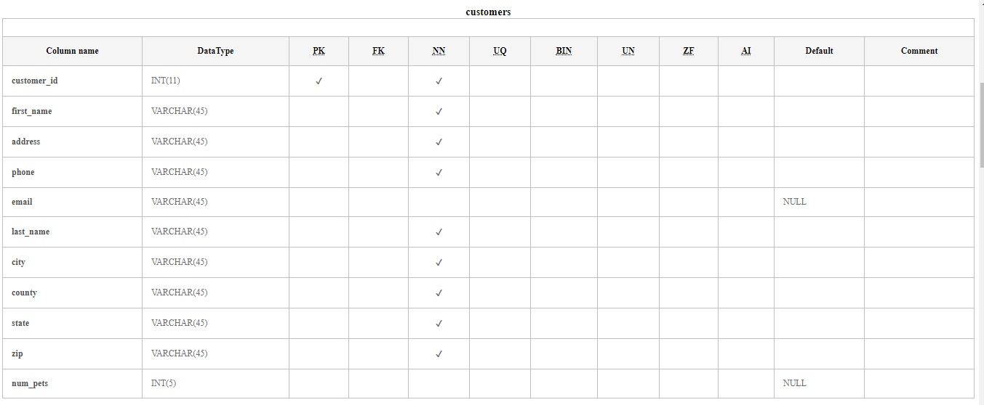

The above table describes about **Customer** table

Customer_id is Primary key

E-mail and num_pets can default be NULL 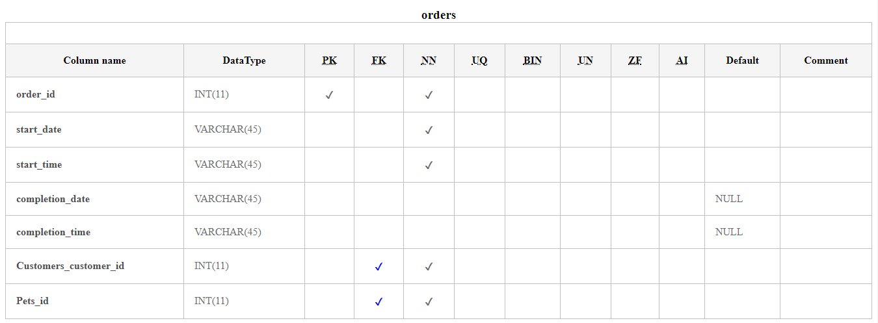

The above table describes about **Orders** table

order_id is Primary key

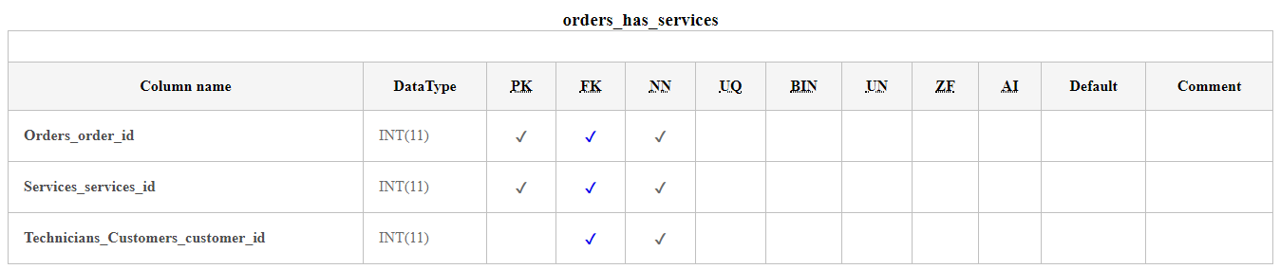

The above table describes about **Orders_has_services** table

order_id and service_id are Primary key

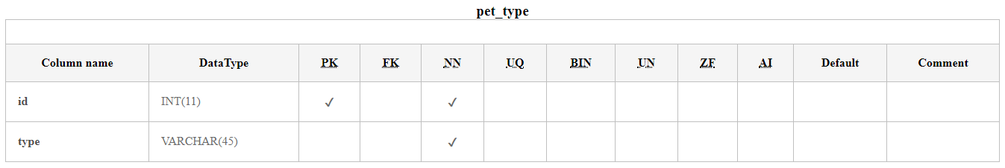

The above table describes about **pet_type** table

Id is Primary key

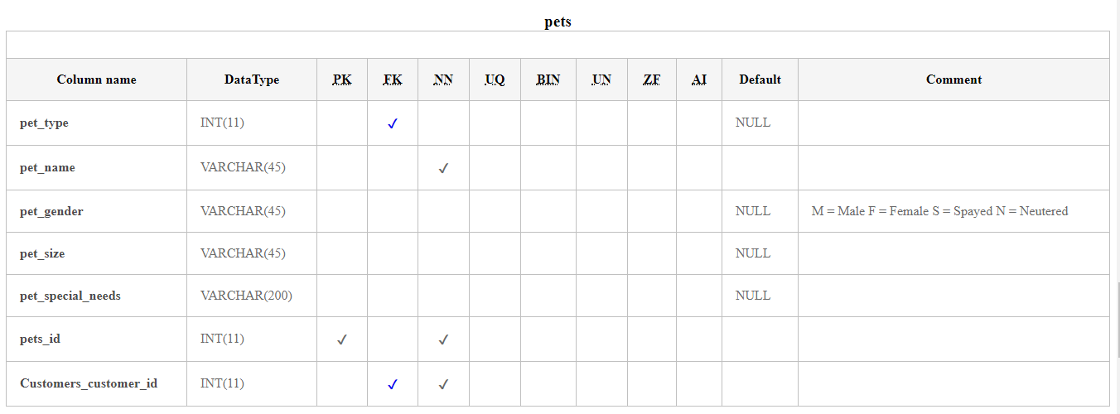

The above table describes about **pets** table

Pets_Id is Primary key

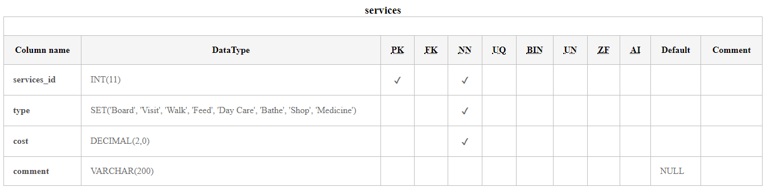

The above table describes about **services** table

services_Id is Primary key

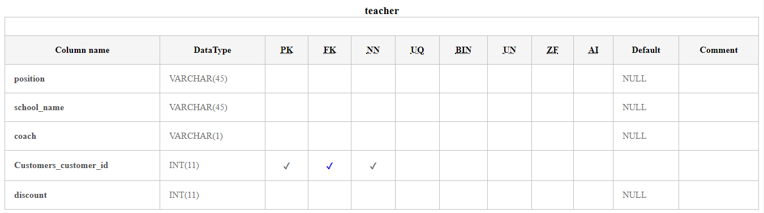

The above table describes about **teacher** table

Customer_Id is Primary key

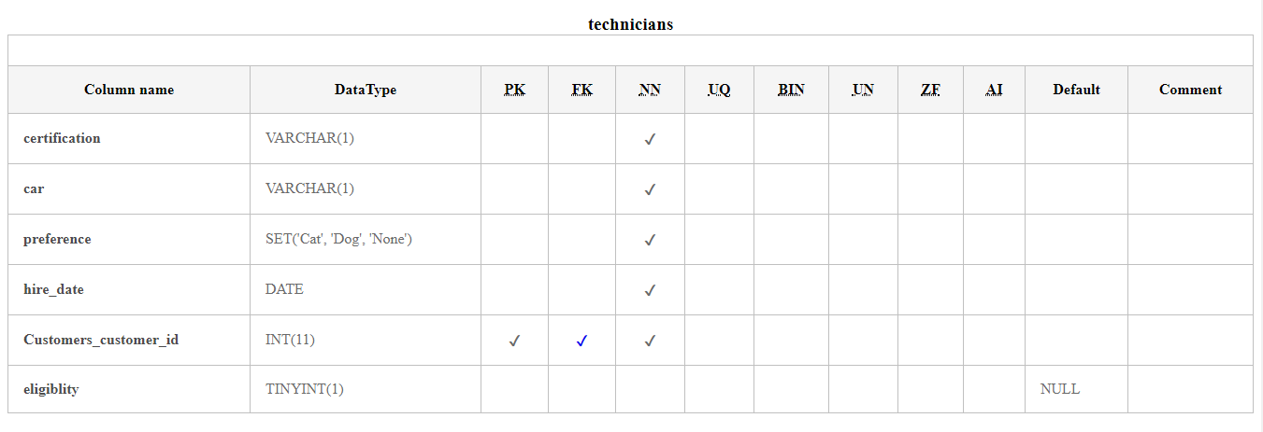

The above table describes about **technicians** table

Customer_Id is Primary key